Curriculum Vitae
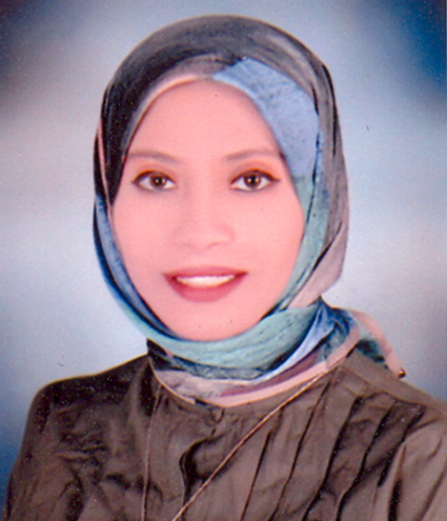

Name: Dalia El-Nobi Ahmed Ibrahim

Nationality: Egyptian

Sex: Female

Date of Birth: August 16th, 1995

Place of Birth: Assiut, Egypt

Marital Status: Single

Contact Address: Department of Microbiology and Immunology, Faculty of Pharmacy, Assiut University, Assiut, Egypt

Cell Phone Number: +201061329191

E-mail: Daliaelnobi75@yahoo.com
daliaelnopy@gmail.com
Dalia.ElNuby@pharm.aun.edu.eg

Languages: fluent in Arabic and English

Education:
- Bachelor in Pharmacy, Faculty of Pharmacy, Assiut University, Assiut, Egypt, June 2018.
- Grade: Excellent with Honors.

Academic Positions
March 2019 - | Demonstrator at Department of Microbiology and Immunology, Faculty of Pharmacy, Assiut University, Assiut, Egypt.

Computer skills:
- Microsoft office word
- Power-point
- Excel
- Access
- Internet

